EXPERIMENT - 1
Aim: Study of advanced standard Library data structures

Objectives:
- To Revise concepts of Time complexity of various algorithms
- To study and implement advanced standard Library data structures such as Dynamic arrays, vectors, list, sets and maps.
- To design and implement efficient solutions using advanced Standard Library data structures

Lab outcome:
At the end of the lab session, students will be able to
- Deepen their understanding of dynamic arrays, sets, maps, iterators, and range.
- To design and implement efficient solutions using advanced Standard Library data structures such as dynamic arrays, maps, sets, and iterators, with a focus on optimizing time and memory complexity for real-world problems (e.g., LRU cache, top-K elements, sliding window).

Prerequisite: Data structures, Analysis of algorithms, any programming language (C++/Java/Python)

CO Mapping:
CO1: Solve advanced array and string problems using efficient techniques like the sliding window and two-pointer approach.

Po Mapping: PO1, PO2, PO3, PO5
Theoretical Description:
Refer PPTs Uploaded in classroom.

Students’ Task:
- Find the top K elements dynamically with maps and sets.
- Build an LRU cache with std::map for fast lookups.
- Solve the sliding window maximum problem with efficient complexity using range-based operations
Algorithms:

- Given a stream of elements, find the top K elements dynamically (i.e., after each insertion or at any point) using maps and sets.

Key Idea:
- Use a map to store frequency of elements.
- Use a set with custom ordering to keep elements sorted by:
  - Frequency (descending)
  - Value (ascending, to break ties)
This allows:
- Efficient updates when frequencies change
- Easy retrieval of top K elements

Data structure Used:
map<int, int> freq;
set<pair<int, int>> sortedSet;

Algorithm:
- For each incoming element:
  - If it already exists, remove its old (frequency, element) from the set.
  - Update its frequency in the map.
  - Insert the updated (frequency, element) back into the set.
- Traverse the set from the largest frequency.
- Print the first K elements.
Time Complexity of above approach : O(N log N).

- Solve the sliding window maximum problem with efficient complexity using range-based operations

Problem statement: Given an array of size n and a window size k, determine the maximum element in every contiguous subarray (window) of size k efficiently.

Approach
A deque (double-ended queue) is used to maintain indices of elements in decreasing order of their values within the current window. This allows constant-time access to the maximum element for each range (window).
Example:
Array:
A = [1, 3, -1, -3, 5, 3, 6, 7]
Window size: k = 3
Expected Output:
[3, 3, 5, 5, 6, 7]
Steps:
A = [1, 3, -1, -3, 5, 3, 6, 7] output = [3
A = [1, 3, -1, -3, 5, 3, 6, 7] output = [3,3
A = [1, 3, -1, -3, 5, 3, 6, 7] output = [3,3,5
A = [1, 3, -1, -3, 5, 3, 6, 7] output = [3,3,5,5
A = [1, 3, -1, -3, 5, 3, 6, 7] output = [3,3,5,5,6
A = [1, 3, -1, -3, 5, 3, 6, 7] output = [3,3,5,5,6,7]

Algorithm:
- Initialize an empty deque dq.
- Traverse the array elements from left to right.
- Remove indices from the front of the deque if they fall outside the current window.
- Remove indices from the rear of the deque while the current element is greater than or equal to the elements represented by those indices.
- Insert the current index at the rear of the deque.
- Once the first window is completed (i ≥ k−1), record the element at the front of the deque as the window maximum.
- Repeat until all windows are processed.
Time Complexity:
• Each element is added once and removed once in a dequeue.
• No repeated scanning of windows
• The deque always keeps the maximum of the current range at the front

Time Complexity: O(n)
Space Complexity: O(k)

- Build an LRU cache with std::map for fast lookups.
Least recently Used:
Cache Capacity = 3
Access sequence: 1, 2, 3, 1, 4, 5
Step | Accessed Page | Cache State (MRU → LRU) | Page Fault
1 | 1 | [1] | Yes
2 | 2 | [2, 1] | Yes
3 | 3 | [3, 2, 1] | Yes
4 | 1 | [1, 3, 2] | No
5 | 4 | [4, 1, 3] | Yes (2 removed)
6 | 5 | [5, 4, 1] | Yes (3 removed)

Data Structures Used
- Doubly Linked List (or std::list)
  - Maintains the order of usage
  - Front → Most Recently Used (MRU)
  - Back → Least Recently Used (LRU)
- std::map<Key, list iterator>
  - Provides fast lookup of cache entries
  - Stores key → iterator pointing to the corresponding node in the list

Approach:
- The map allows quick checking of whether a key exists in the cache.
- The list allows efficient insertion, deletion, and movement of elements to maintain LRU order.

Step-by-Step Approach
- Initialize:
  - A list to store cache keys in MRU → LRU order
  - A map to associate each key with its position in the list
  - A fixed cache capacity
- GET operation:
  - Check if the key exists in the map
  - If not found → return cache miss
  - If found:
    - Move the corresponding node to the front of the list
    - Update the map entry
    - Return the value
- PUT operation:
  - Check if the key already exists:
    - If yes, update its value
    - Move it to the front (most recently used)
  - If the key does not exist:
    - If cache is full:
      - Remove the last element from the list (LRU)
      - Erase its entry from the map
    - Insert the new key at the front
    - Store its iterator in the map
- Maintain consistency:
  - Any access (read/write) updates the usage order
  - Map and list are always synchronized

Why std::map?
- Provides logarithmic time lookup (O(log n))
- Maintains ordered keys (useful for debugging and traversal)
- Ensures predictable performance

Complexity Analysis
Operation | Time Complexity
Get | O(log n)
Put | O(log n)
Eviction | O(log n)
Space Complexity O(capacity)
Bottom of Form

Post Lab questions:
  - Compute and explain step by step Time complexity of your code
    - For top k frequent elements
    - Sliding window Maximum
    - LRU cache

Sol.
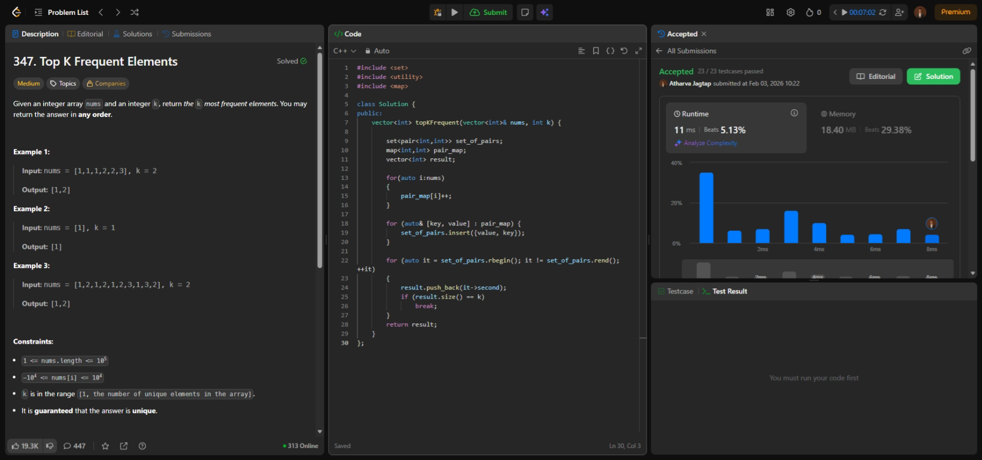

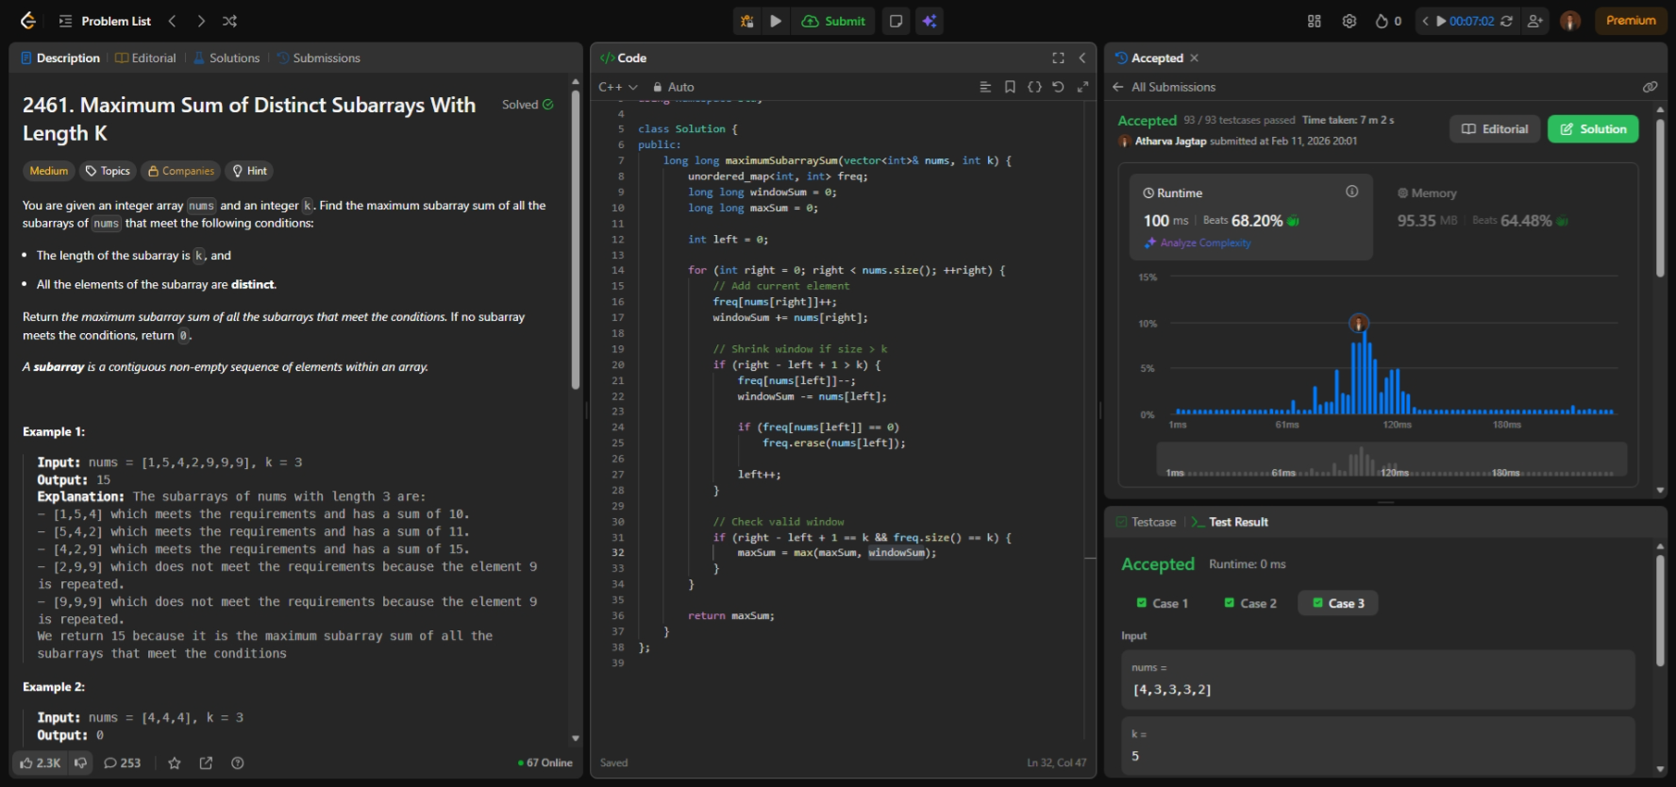

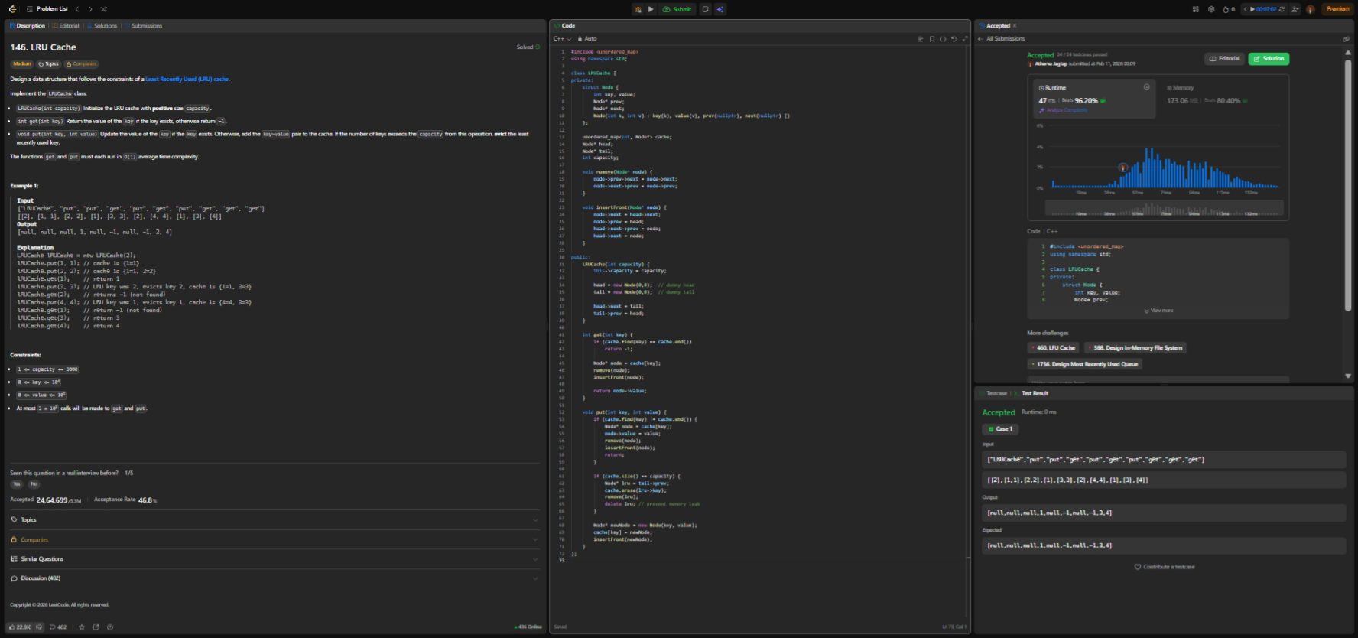

  - Solve the following problem on Leetcode platform
Valid Anagram: Given two strings s and t, return true if t is an anagram of s, and false otherwise.
Anagram: a word or phrase that is made by arranging the letters of another word or phrase in a different order.
Input: s = "anagram", t = "nagaram"
Output: true
Hint: Use unordered map
Link to Leet code: https://leetcode.com/problems/valid-anagram/description/

Code & Output:
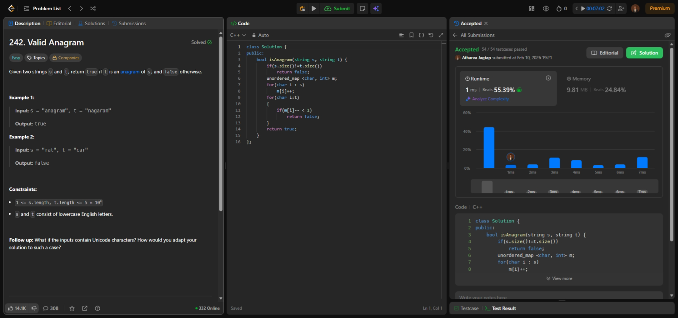
Conclusion: (Write your conclusion here)
The experiment strengthened the understanding of advanced Standard Library data structures and their impact on algorithm efficiency. By implementing solutions such as top-K frequent elements, sliding window maximum, and LRU cache, the importance of selecting appropriate data structures to optimize time and space complexity became evident. The lab improved analytical and problem-solving skills while bridging theoretical concepts with practical implementation, enabling the design of efficient and scalable solutions for real-world problems.

References:
[1] Top k frequent elements: https://www.youtube.com/shorts/8nXGn11O_Xo
[2] Maximum sliding window : https://www.youtube.com/watch?v=XwG5cozqfaM
[3] LRU : https://www.youtube.com/watch?v=GsY6y0iPaHw

